Registration to the Symposium
Please note that registration should be made only through the official Symposium web site:
http://www.hrlm-3rd.gda.pl

The Symposium registration fee includes all the costs for coffee breaks, lunch, cocktails and a dinner during the symposium (incl. the workshop). A boat trip will be arranged on Wednesday evening. Moreover, fees include all material needed for the conference as well as the proceedings that will appear in the Springer Series on “Numerical Notes in Fluid Mechanics and Multidisciplinary Optimisation” (NNFM).

With the ardent support of our sponsors, the organizing committee may offer a considerable reduction of the Symposium fee for university students.

The following registration fees apply:
380€ Participants and contributors
380€ Software vendors – including stands
240€ Students
Please note: After 4 May 2009, fees will have to be 430€ and 290€, respectively.
___________________________________
45€ accompanying persons dinner
15€ accompanying person boat trip

During the symposium, an Exhibition of Commercial CFD Software will be held. Thus, commercial CFD software vendors are welcome to demonstrate their product at the Symposium venue.

For further details, please contact the symposium chairmen or local organizer via e-mails:

Prof. Piotr Doerffer (doerffer@karol.imp.gda.pl),

Dr. Werner Haase (office@haa.se) or

Prof. Shia-Hui Peng (peng@foi.se)

The Symposium on Hybrid RANS-LES Methods has been an important exploitation mean of the European DESider project (2004-2007), on which information is still available at the project Web site:
http://cfd.mace.manchester.ac.uk/desider/

The Symposium has its focus on flow physics modelling and related aerodynamic applications, particularly, in terms of advanced URANS, improved DES and hybrid RANS-LES approaches in general.

The Symposium is open to academic researchers, graduate students, industrial engineers, industrial R&D managers and consultants with an active interest in the fields of turbulent-flow modelling, simulations and measurements and multidisciplinary CFD applications, such as flow control, aero-acoustics, aerodynamic optimization and aero-elasticity.

Besides different sessions, the symposium includes also Test Case (TC) Sessions (mini-workshop) dedicated to a specific test case stemmed from the European UFAST project. We encourage interested participants to present their results in the workshop. For further information, please refer to the official Symposium Web site:

http://www.hrlm-3rd.gda.pl

Organising and Scientific Committee

B. Aupoix ONERA, France

M. Braza IMFT, France

L. Davidson Chalmers Univ. of Tech., Sweden

P. Doerffer Local Chair, IMP-PAN, Poland

S. Fu Tsinghua Univ., Beijing, China

T. Gatski Laboratoire d'Etude, Aero-

dynamiques, CNRS, France

W. Haase Chair, EADS Military Air

Systems, Germany

Ch. Hirsch NUMECA, Belgium

D. Laurence EDF, France and University of

Manchester, UK



M. Leschziner Imperial College, U.K.


F. Menter ANSYS, Germany

S.-H. Peng Co-chair, FOI, Sweden

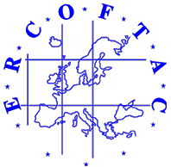
D. Schwamborn DLR, Germany

P. Spalart Boeing, USA




M. Strelets NTS, Russia

F.Thiele TUB, Germany
Third Symposium on
Hybrid RANS-LES Methods

Hotel Mercure, Gdansk, Poland,
10-12 June 2009

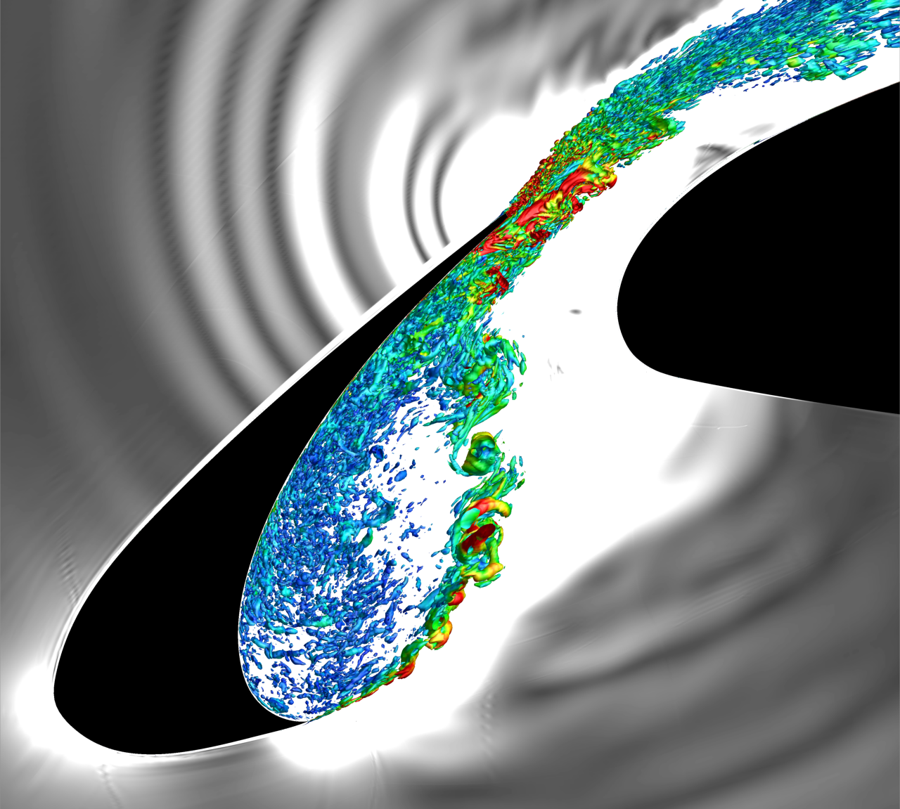

Register at http://www.hrlm-3rd.gda.pl

Co-organised by
EADS Military Air Systems, Germany
Swedish Defence Research Agency (FOI), Sweden
IMP-PAN, Poland
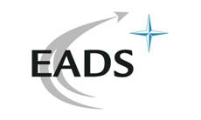



Supported and sponsored by
Third Symposium on
Hybrid RANS-LES Methods
Hotel Mercure, Gdansk, Poland,
10-12 June, 2009

Hybrid modelling methods of turbulent flows, combining RANS and LES techniques, have received increasing attention over the past decade to fill up the gap between (U)RANS and LES computations in aerodynamic applications at industrially relevant Reynolds numbers.

The present Symposium addresses the most recent and new development on advanced URANS, DES and other hybrid RANS-LES techniques, which covers both the fundamentals of modelling approaches and their applications to industrial flow problems.

As with the First Symposium (Stockholm, 2005) and the Second (Corfu, 2007), the aim of the Third Symposium is to continue with the provision of a forum for researchers and industrial engineers to exchange knowledge and expertise, to discuss and to present recent achievements in the development and applications of hybrid RANS-LES methods - including physical models and related numerical issues. Hence, this Symposium will encourage an emergence of new ideas and inspire participants to pursue and intensify efforts towards future developments and applications of hybrid RANS-LES methods.

Main Topics
- Advanced URANS modelling
- Improved DES modelling
- Hybrid URANS-LES methods
- DES versus Unsteady RANS and/or LES
- Modelling-related numerical issues
- Industrial applications
- Mini-workshop on a specified test case
- Commercial CFD software exhibition

Special Lecture
Pawel Gepner (INTEL, Poland):
"What does Intel multi-core strategy bring to CFD"

Invited Speakers
Prof. Song Fu (Tsinghua University, China):
"Investigation of Practical Flow Control Methodologies with RANS/LES Hybrid Approach"
Dr. Mattias Sillen (Saab Aerosystems, Sweden):
"Flow Modeling in Aircraft Design - an Engineering Perspective"
Dr. Philippe Spalart (Boeing Company, USA):
"Reflections on RANS Modeling"
Prof. Frank Thiele (TU Berlin, Germany):
“Advanced DES Methods and Their Application to Aeroacoustics”

Abstracts, Presentations, Papers, Workshop
- An Abstract of 1-2 (max) pages must be submitted.
- Full Papers (10 pages for Distributed, 15 pages for Invited Papers) should be submitted at the conference or shortly after the symposium.
- 50 minutes are allocated to Invited Keynote Lectures and 25 minutes for Other Presentations, including time for discussion.
- Following a peer review, discussed and Revised Full Papers will be published in the Springer Book Series "Notes on Numerical Fluid Mechanics and Multidisciplinary Design".
- For the Mini-Workshop, please refer to the Symposium Web site http://www.hrlm-3rd.gda.pl for details.
- Abstracts and full papers should be sent to both

Werner Haase (office@haa.se) and
Shia-Hui Peng (peng@foi.se)

Important Dates
30 March 2009 Deadline for submission of
abstract or full paper
6 April 2009 Paper acceptance
15 April 2009 Hotel booking deadline
(block booking terminates on 15 May!)
10-12 June 2009 Symposium / Full papers

15 August 2009 Revised full papers

Tentative Programme
09 June 2009
18:00 - 20:00 | Early registration

10 June 2009
08:00 – 09:00 | Registration
09:00 – 09:10 | Welcome – Opening
09:10 – 10:00 | Invited keynote lecture I, Philippe Spalart
10:00 – 10:20 | Coffee
10:20 – 12:25 | Session I (5 contributions – 25 min each)
12:25 – 14:00 | Lunch
14:00 – 14:50 | Invited keynote lecture II, Song Fu
14:50 – 16:05 | Session II (3 contributions – 25 min each)
16:05 – 16:25 | Coffee
16:25 – 18:30 | Session III (5 contributions – 25 min each)
20:00 | Boat trip

11 June 2009
09:10 – 10:00 | Invited keynote lecture III, Frank Thiele
10:00 – 10:20 | Coffee
10:20 – 12:25 | Session IV (5 contributions – 25 min each)
12:25 – 14:00 | Lunch
14:00 – 14:50 | Invited keynote lecture IV, Mattias Sillen
14:50 – 16:05 | Session V (3 contributions – 25 min each)
16:05 – 16:25 | Coffee
16:25 – 18:30 | Session VI (5 contributions – 25 min each)
20:00 | Dinner downtown

12 June 2007
08:20 – 09:00 | “What does Intel multi-core strategy bring to CFD”, Pawel Gepner  - Presentation and open discussion -
09:00 – 09:20 | Introduction on Test Case (TC), P. Doerffer
09:20 – 10:35 | TC-Session I (3 contributions – 25 min each)
10:35 – 10:50 | Coffee
10:50 – 12:55 | TC-Session II (5 contributions–25 min each)
12:55 – 13:10 | Poster award / Closing remarks
13:10 – … | “Farewell” Lunch

